Renju lesson on December 27, 2001

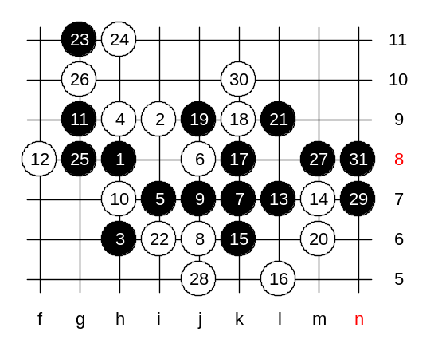
Hello everyone! Welcome to Online Renju Class. We go on with i10 opening. Last time we learned 6-g9. We made sure that g9 is weak. The strong 6th move is j8. We will study it today. It must be strong enough so that Nakamura is brave enough to use it against me. We go j8. What can black do now? Does black have any other ideas besides 9-k7? Move 9-g9 used to be very popular at some time. I spent lots of time to find win for g9, but couldn’t. Maybe some day someone can find it. Today I will tell you about the traditional style in this pattern – 9-k7. White must respond with either j6 or j7. Right? Well, since j6 was your last homework, lets check it. Those who found the win in advanced homework by themselves, are likely over 4 dan level. Excluding those who used VCT software, books, or friend’s help. We show the answer now.
You say g11, what is the idea of g11? Can you explain? Yes, it’s a control. Takes care of white’s counter attack. Yes, g8 was the key of homework.

Now, the variant with 12-g8. How many of you know it? It is very hard indeed. It made some big changes recently. The variant that all books claimed to be black win, turned out to be white win. Let us see the bug first. Note that so many high level players still do not know about this bug. Move i10, very active. It is strong enough to give white win. But old theory did not allow it, claiming that black has win after that.
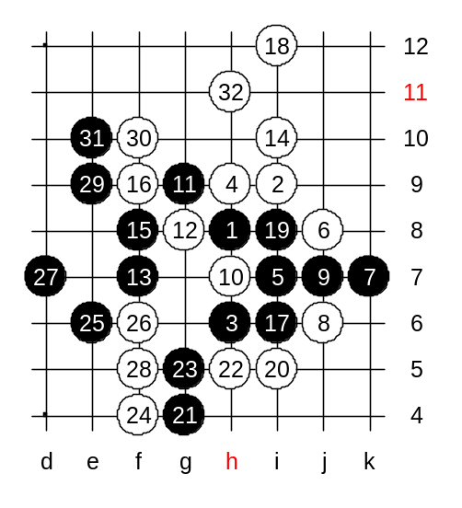
The black’s idea is to use control style through i8. Indeed, if white attacks, then black plays i8 and gets the tempo. But those who made old theory, forgot one thing. Tempo is useful only if you have something to do with it. People, having assumed that black is strong enough, did not dig any deeper. But it turned out that white can simply use waiting tactics and defend. After black attack fails, white can enjoy win above. How can black attack now? Cannot go e7 yet, it is controlled by white. So, we must play g4. White goes h5 of course. Who knows white defense here? Yes, f4, true. Black seems to have 3 move win, but no sequence, right? Shall we try e6 now? Yes, white must go f6! The d7 – the only way to keep black attack. We block at f5. E9, seems interesting. White’s f10 is beautiful – blocks black VCF and makes self VCF. Black must go e10.
White’s h11 cuts blacks and makes self VCF.

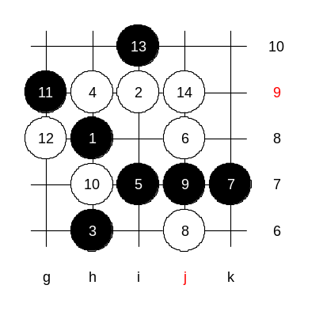
Now, let see, if this variant was bad, then what should black do instead. The simplest solution is to use positional style with i10. This move became popular after the bug was discovered. There is no theory about i10. All we have now is a dozen of tournament games played under this variant. Since black is forced to change 13th move, the i10 seems to be the best choice. Positional style is hard. All games of i10 have been played with white next move to j9. Why j9 is good? Black has two attacking areas – left and right. If white just blocks one are then black wins on another. The j9 is a balanced move. Black often plays k10 here. But there is no proof yet that k10 is the best. It is too early to say. K10 is a safe move at least, it follows the principles of positional style. It is hard to tell what is the best here. As long as black makes sure white doesn’t have vct, black can use aggressive style. But people seldom go on this – they prefer safe style without risks. I let everyone of you choose your own favourite style here. If you cannot come up with anything good, then just play safely to L9 or k10. Move f8 looks risky but interesting.

